# Marketing

**Spotify seems to hold grip of most of college students I interact with and beyond. In less than two years almost everyone I talk to is at the very least familiar with Spotify or are subscribers. Spotify was originally started in Sweden in 2008; I got to learn about it from having dated a Swedish foreign exchange student and she had heard all of the buzz from her home country. Spotify has leveraged its ability to be distinct because it offers a music platform that works flawlessly across devices with a powerful social network integration all offered at a reasonable price, or free if you’re willing to listen to ads. They were able to understand that individuals wanted a platform that was in sync across your all of your devices, phone, tablet, and laptop. Since it excels cross platform it was a strong competitor to their main competitor, Rhapsody and their less competitive competitor Pandora which lacks good user interface outside of their website interface. Over time Spotify has received strong content additions, adding many more major labels and at the same time adding the smaller labels that Pandora is often playing. Spotify never let itself be identified to one country, they immediately were able to make sure that their service was not branded simply to the European countries it was launched in. Why was Spotify so successful? It seems so simple but they were able to identify with market research the sweet spot between what was being offered and what consumers wanted. They had the**

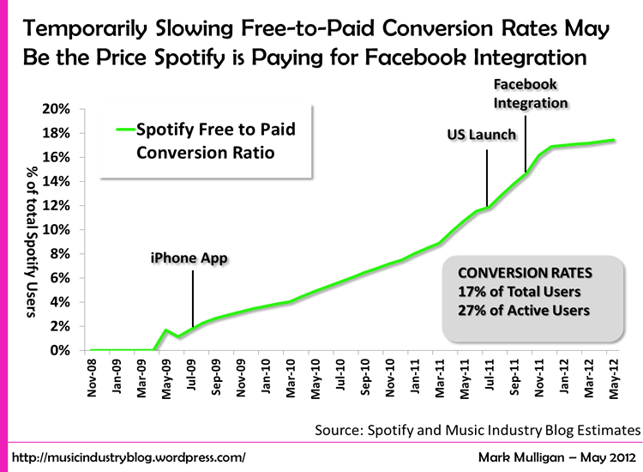

Discuss a successful international product or service that has been adopted in the US

Why was it successful?

What makes it distinct?

Does it have competitors and if so, who are they?

Does the product seem connected to its home country still? Or has it become Americanized?